Persevere Architectural Overview
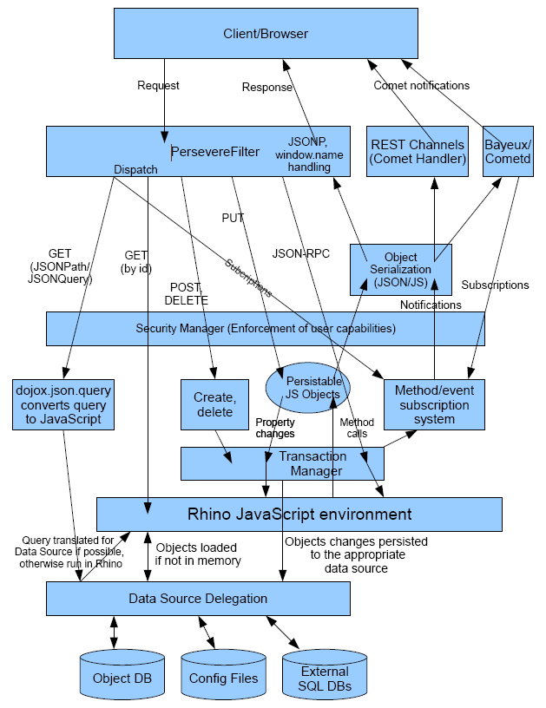
Persevere is Java based server that provides JSON storage and JavaScript persistence capabilities in a JavaScript environment running on Rhino. Persevere provides a RESTful interface to it's storage objects and data, a JSON-RPC interface for executing methods on persisted objects, a RESTChannels interface for data change notification, and a Bayeux interface for pub/sub messaging through objects. This document provides an architectural overview of Persevere for those interested and future contributors.
The core of Persevere is persistable JavaScript objects, mapped to data storage endpoints. RESTful requests retrieve and serialize these JavaScript objects. RESTful modifications (PUT) modify these objects. When these persistable objects are modified their changes are automatically persisted to the data storage endpoints. JSON-RPC requests execute methods on the objects. All objects created in Persevere's JavaScript are persistable. Objects can be instantiated from classes, creating new entities in the corresponding storage tables, and "plain" objects can created that can be used a values in other objects. The primary class for persistable objects is the PersistableObject class. This class manages property changes, validating them against the class's schema, and recording the changes in the current transaction (the Transaction class). PersistableObject also handles lazy loading when properties are accessed, loading properties from the proper storage endpoint.
Persevere's forward facing request handler and dispatcher is PersevereFilter. This filter class handles the different types of HTTP methods, and translates the URLs to the corresponding objects from their table. It translates the requests into queries, object loads, object modifications, object instantiations, object deletions, method calls, and so forth. The results of these operations are then delivered back to the client through the Persevere serialization mechanism and the PersevereFilter will deliver the serialized result back to the client. PersevereFilter also provides error handling, and wrapping the response in JSONP or window.name envelopes for cross-domain requests.
Persevere's serialization mechanism provides content negotiation and serialization to JSON/JavaScript. The serialization works by looking for content representation handlers on objects, in the form obj['representation::mime/type']. For example, if a request comes with a header of GET /Customer/2
Accept: application/json
The server will load the object from the Customer table with an id of 2. It will then look for a object object[''representation::application/json"], if it finds it, will execute it's "output" method. Persevere provides handlers for application/json and application/javascript on Object.prototype, and these are automatically called by default for all objects if no specific content type (the typical Accept: */*) is required. The application/javascript only differs from application/json in that it will serialize functions and dates as JavaScript. The implementation for JSON serialization is provided by the JSONSerializer class, and is installed on Object.prototype in the RestMethod class.
Persevere's security manager provides permission checking to ensure proper authorization for user induced operations. The security manager determines access to operations by checking against the capabilities of the user. The user objects (CapabilityUser) has methods that are used to check the access level of an object (getPermissionLevel()), and this is called for every action taken against a obejct, including property reads, property writes, and method execution. The different access levels define which of these operations can be performed on an object, and these are checked by the PersistableObject class in the case of property access/mutation. When methods are executed from a JSON-RPC, first there is a check against the security system to see if the current user has permission to execute the method, but once the method is executed, it is runs in privileged mode, where no security checks take place (unless an explicit check is made (with getAccessLevel()). When an object's security is checked, if there is no explicit capability defined, then the object's parent is checked, thus permissions effectively are
User can also be granted other capability objects; CapabilityUser or it's superclass CapabilityObject, stored in User and Capability, respectively. Thus a set of capabilities can be granted to different users.
Queries can be executed by requests with URLs postpended with JSONQuery expressions, or through the "load" function in the server side JavaScript environment. Queries are processed by the JSONPath class which uses the dojox.json.query module running on the server, to convert the query to a JavaScript function that can be executed on the list of items in the target table to find the matching result set. However, performing the query in JavaScript is often less than ideal for performance reasons, especially if the underlying data source has indexing capabilities which can provide O(log n) (vs O(n)) performance. Consequently, the JSONPath class will convert the result query function into an abstract syntax tree (AST) representation (encapsulated in the Query class, with tree nodes comprised of Rhino's Node class) which is passed to the corresponding data source. If the data source can utilize the AST query to directly execute the query, it can do so and return the resultant result set. Otherwise the query is rejected by the data source (via a thrown exception) and the query is executed by the JavaScript environment.
Result sets are internally represented with JavaScript arrays (PersistableArray which extends Rhino's NativeArray) and lazy loading is used to be load result set items as needed from the data source as indices in the array are accessed in order to minimize the amount database transfer in paged result sets.
Transactions are managed by the Transaction class and are tracked as a ThreadLocal state associated with the executing request/response (which operates in a single thread for the life of the processing in Persevere, sans Comet handlers). As persistent object's property changes occurred the value for the property becomes TransactionalValue, and this is special value that is resolved based on the current thread. If the current thread has changed the value, the current thread will see the new value while all other threads will see the old value until the transaction is actually committed. This allows for isolation of transactions, a server side method can make changes to values that are not visible outside the transaction until it is actually committed.
By default every request/response is wrapped in a single transaction, although Persevere allows for combining multiple requests into a single transaction (this is handled in PersevereFilter). Persevere also supports conditional operations (also in PersevereFilter) for concurrency robustness. In the future, I plan to apply the software transactional memory technique to the JavaScript transactional process for easier and more robust transactions as well as improved atomicity.
Persevere's data source system is designed to allow plug-in of custom data storage providers. Data sources implement the DataSource interface and are configured in the config files (located in WEB-INF/config). DataSource provides the read API. There is also a WritableDataSource interface that read/write storage systems should implement. Persevere comes with a DataSource implementation for the internal object database (DynaObjectDBSource), for the config files (LocalJsonFileSource), for external JSON/REST servers (like Persevere), and for external SQL databases (DatabaseTableDataSource).
The internal object database is implemented in DynaObjectDBSource and is designed to support ad-hoc dynamic "expando" objects with a variety of data types. Consequently, the database uses a special schema (not traditional ORM column-to-property mapping) to persist objects. The object database's primary table is a table of object properties. The columns consist of the object id, the property name, the property type, and the property value. An object is loaded by retrieving all the properties for the object's id, that is all the rows with an object id column value matching the id of the object to be loaded. This approach allows every object to be composed of any number of dynamically created properties. The object database also includes a table for storing arrays, a table for strings, and a table for large strings (stored in CLOBs). The property value in the object table is a number column and its value represents an id in the case of referencing objects, arrays, and strings (the id of the target entity).
The notification system relies on the Channels servlet to handle the REST Channels Comet interaction with the client, and the JettyBayeux class to interact with Jetty's Cometd/Bayeux implementation for full Bayeux pub/sub messaging. The REST Channels interface provides a superset of the Bayeux implementations capabilities, since the Bayeux system only tracks "message" events, whereas REST Channels notifies of all object events. The Channels class uses the PageSession/EventStream class as the event queue for messages to be delivered to the client. Both Channels and Bayeux rely on the PersistableObject.addListener method to register for events. Method call monitoring is implemented in the Method class, and the method calls that trigger events ("observable" methods) are stored in the current transaction for delivery to the registered event listeners once a transaction is committed (events are triggered until transaction commit).

